Whiterun Hold:

Leader Cards:

1) Jarl Balgruuf



i) []

ii) [Summon a random Imperial Soldier. Summon 2 if fighting against the Rebels.]

2) Jarl Vignar Graymane

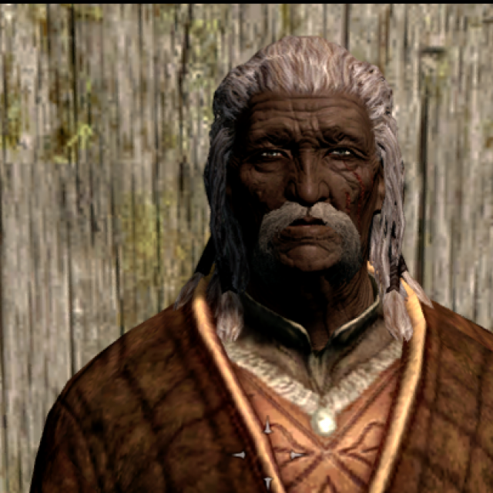

i) [Summon a random Stormcloak Soldier. Summon 2 if fighting against the Empire.]

3) Harbinger Kodlak Whitemane



i) [Can summon a werewolf card from monsters]

ii) Lift Hiricine's Curse off all werewolves if there are any on the opposite side. All werewolf cards strength will be changed to 1.

Unit Cards: 20 (Race, Class, Strength, Level, Ability (if any))

**Melee**

* Whiterun Guard (Nord, Melee, 1, Novice)
* 2) Whiterun Jailor (Nord, Melee, 2, Novice)
* 3) House Carl Irileth (Dunmer, Melee, 6, Expert)

Summon no. of level 2 Guards half to the number of cards on the frontlines zone.

* 4) Uthgerth The Unbroken (Nord, Melee, 6, Expert)
* 5) Farkas (Nord, Melee, 7, Expert) Will double strength when placed with Vilkas
* 6) Vilkas (Nord, Melee, 7, Expert) Will double strength when placed with Farkas

**MAYBENO 7) Commander Caius (Nord, Melee, 5, Adept)**

Summon no. of level 1 Guards equal to the number of cards in the frontline zones.

* 8) Avulstein Graymane (Melee, 4, Adept)
* 9) Hrongar (Melee, 6, Adept)
* 10) Skjor (Melee, 9, Master)

11) Ria (Novice, 2, Apprentice)

12) Njada Stonearm (Melee, 2, Apprentice)

13) Thorald Graymane (Melee, 5, Adept)

**Mages:**

* Farengar Secret-Fire (Destruction-Mage, 6, Adept)

2) Danica Pure-Spring (Healer[Medic]-Mage, 2, Apprentice)

Pick a card from your discard pile and play it instantly.

3) Acolyte Jennsen (Healer-[Medic] Mage, 1, Novice)

Pick a card from your discard pile and play it instantly.

**Shadow:**

1) Aela The Huntress [HERO] (Archer Shadow, 10, Master)

Deadeye: Eliminate any single non-hero unit of the opponent.(Master Ability)

2) Anoriath The Hunter (Archer Shadow, 4, Adept)

3) Elrindir (Archer Shadow, 3, Apprentice)

3) Amaund Motierre (Spy Shadow, 4, Novice)

Place on opposing side, re-draw two cards

4) Jenassa (Sellsword Archer Shadow, 3, Apprentice)

5) Saadia (Alikr Spy Shadow, 4, Novice)

Place on opposing side, re-draw two cards

**Special Cards:**

1) Eorlund Graymane [Place on a zone to double the strength of all cards on that zone.]

OR Commander Caius' Horn

2) Lady Kynareth: [Summon a random nature's creature to fight by your side. Cannot be used along with werewolves or undead.]

3) Olava The Feeble : Use the power of Olava's reading to look at your opponent's 3 random cards.